PHẦN 1: Insert battery

* There are 2 types of batteries: 4S - 5300 mAh and 3S - 5200 mAh. The 4S battery is used for powering the motor, 3S Battery uses the power supply for the Jetson TX2 board.

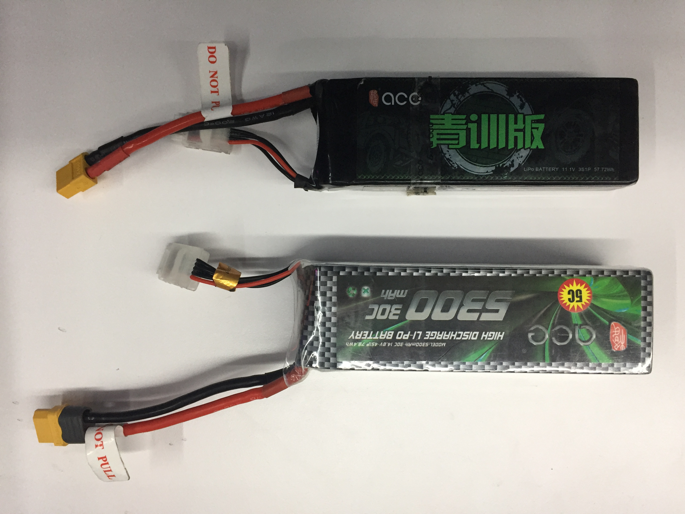

* Insert battery 4S

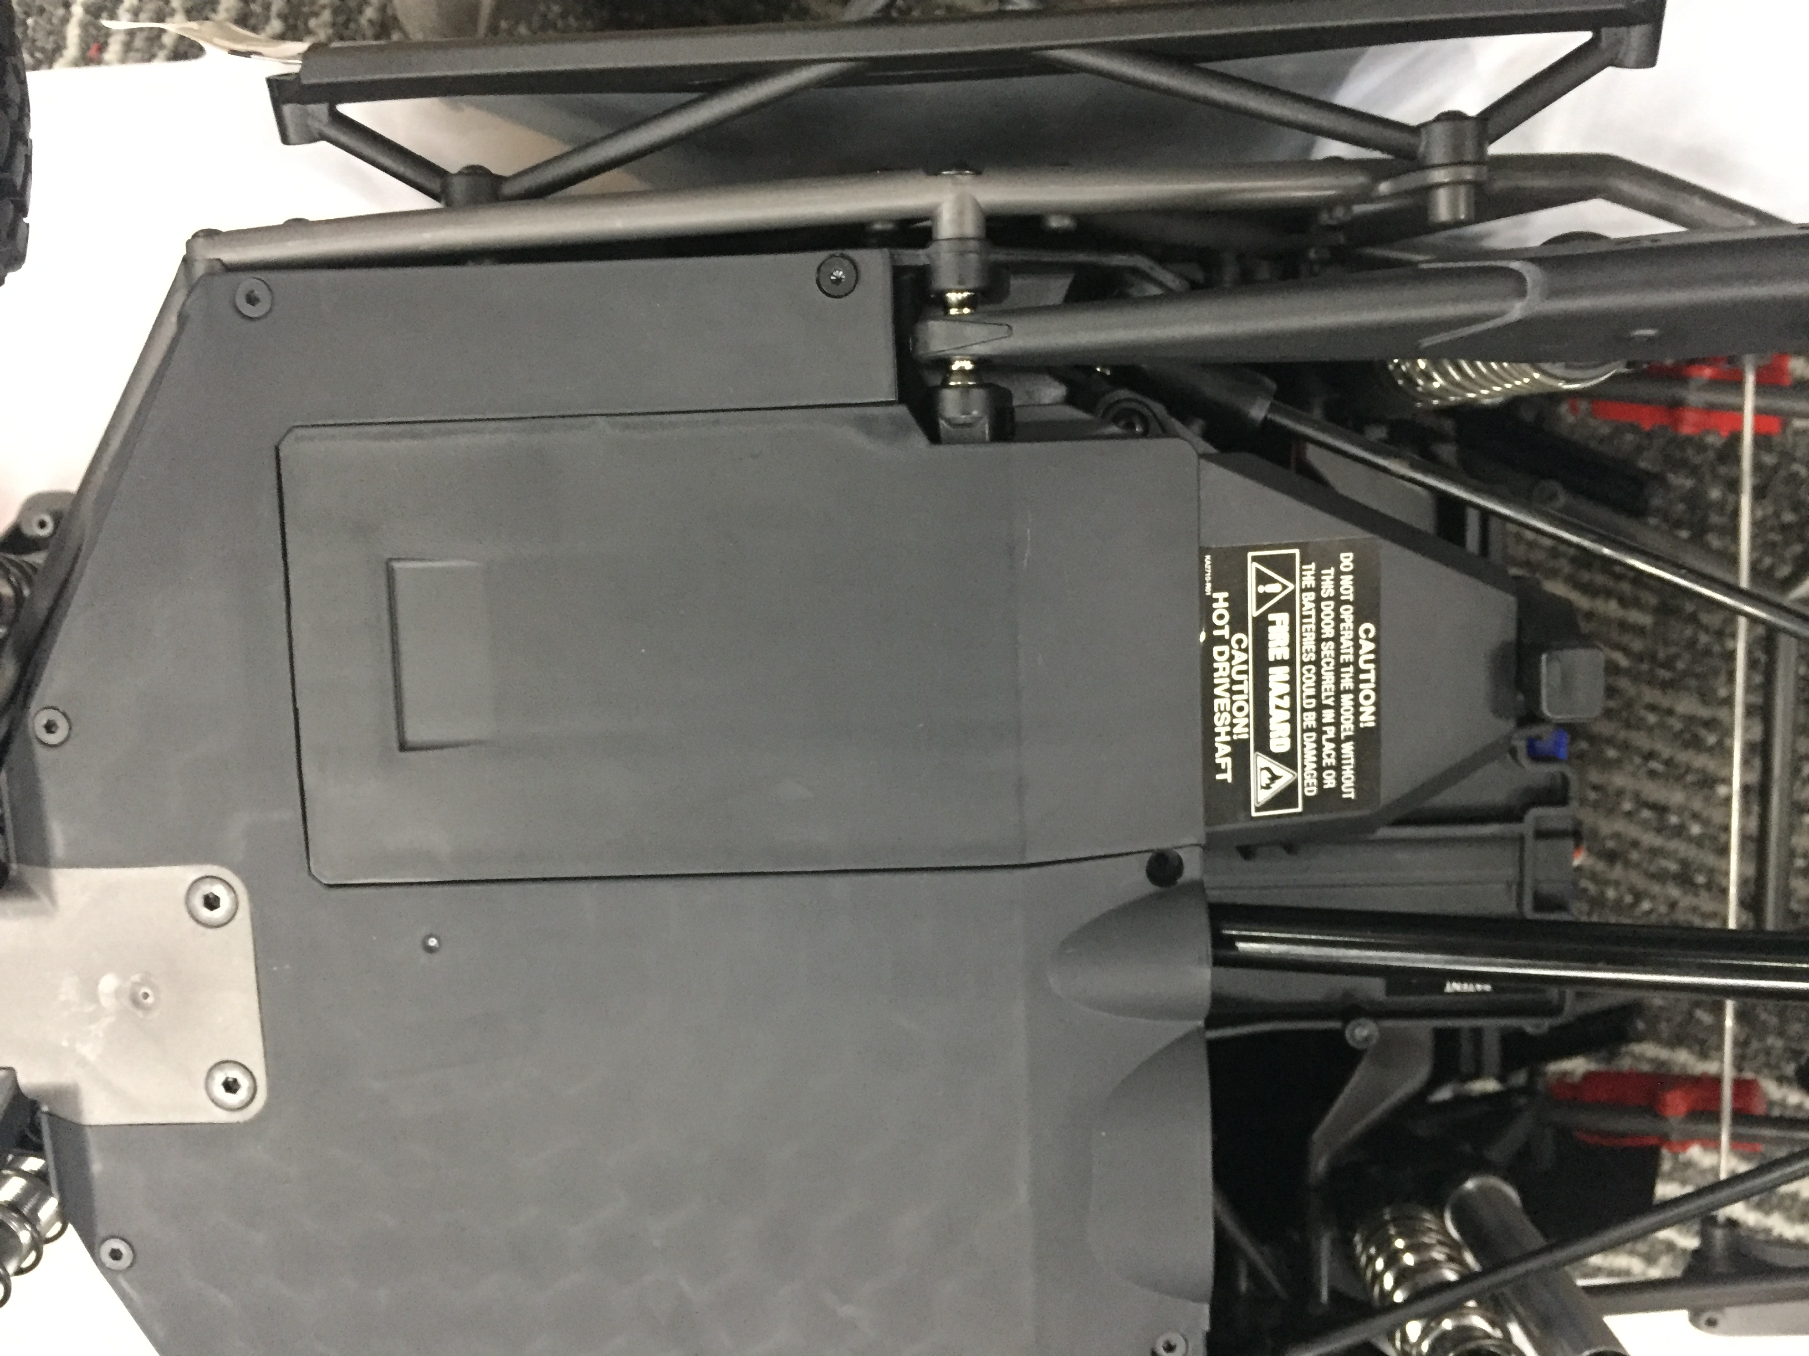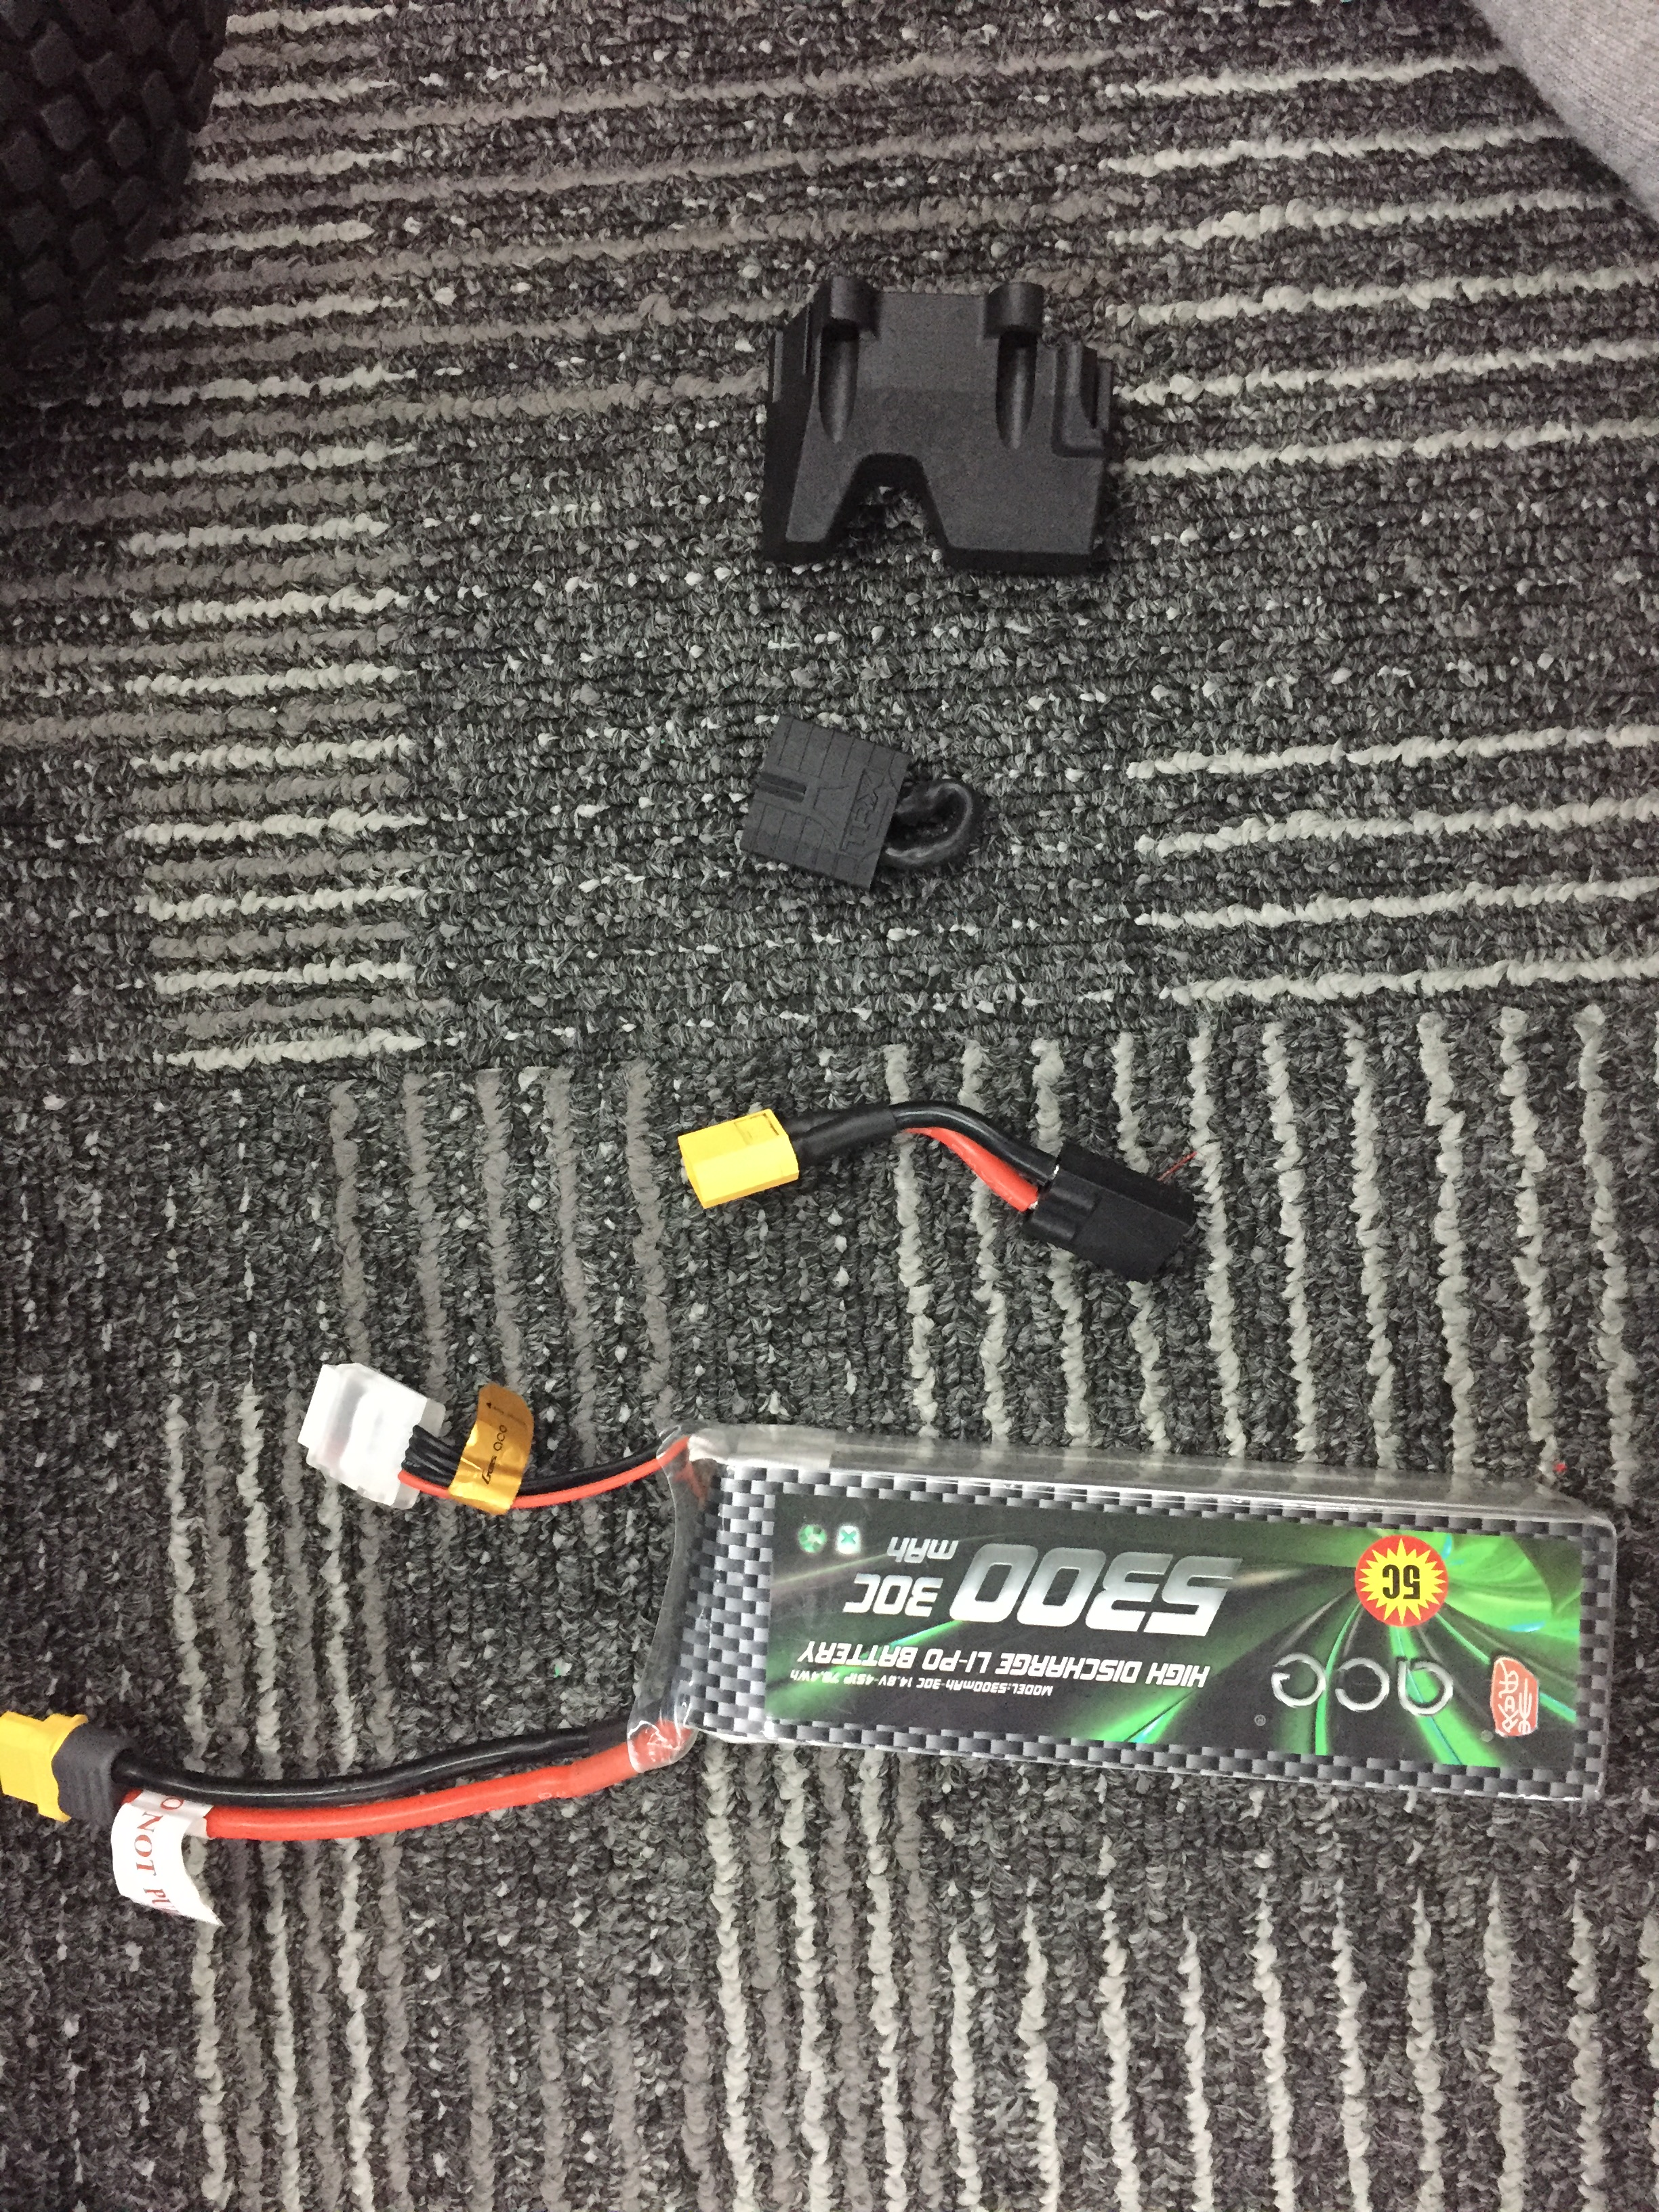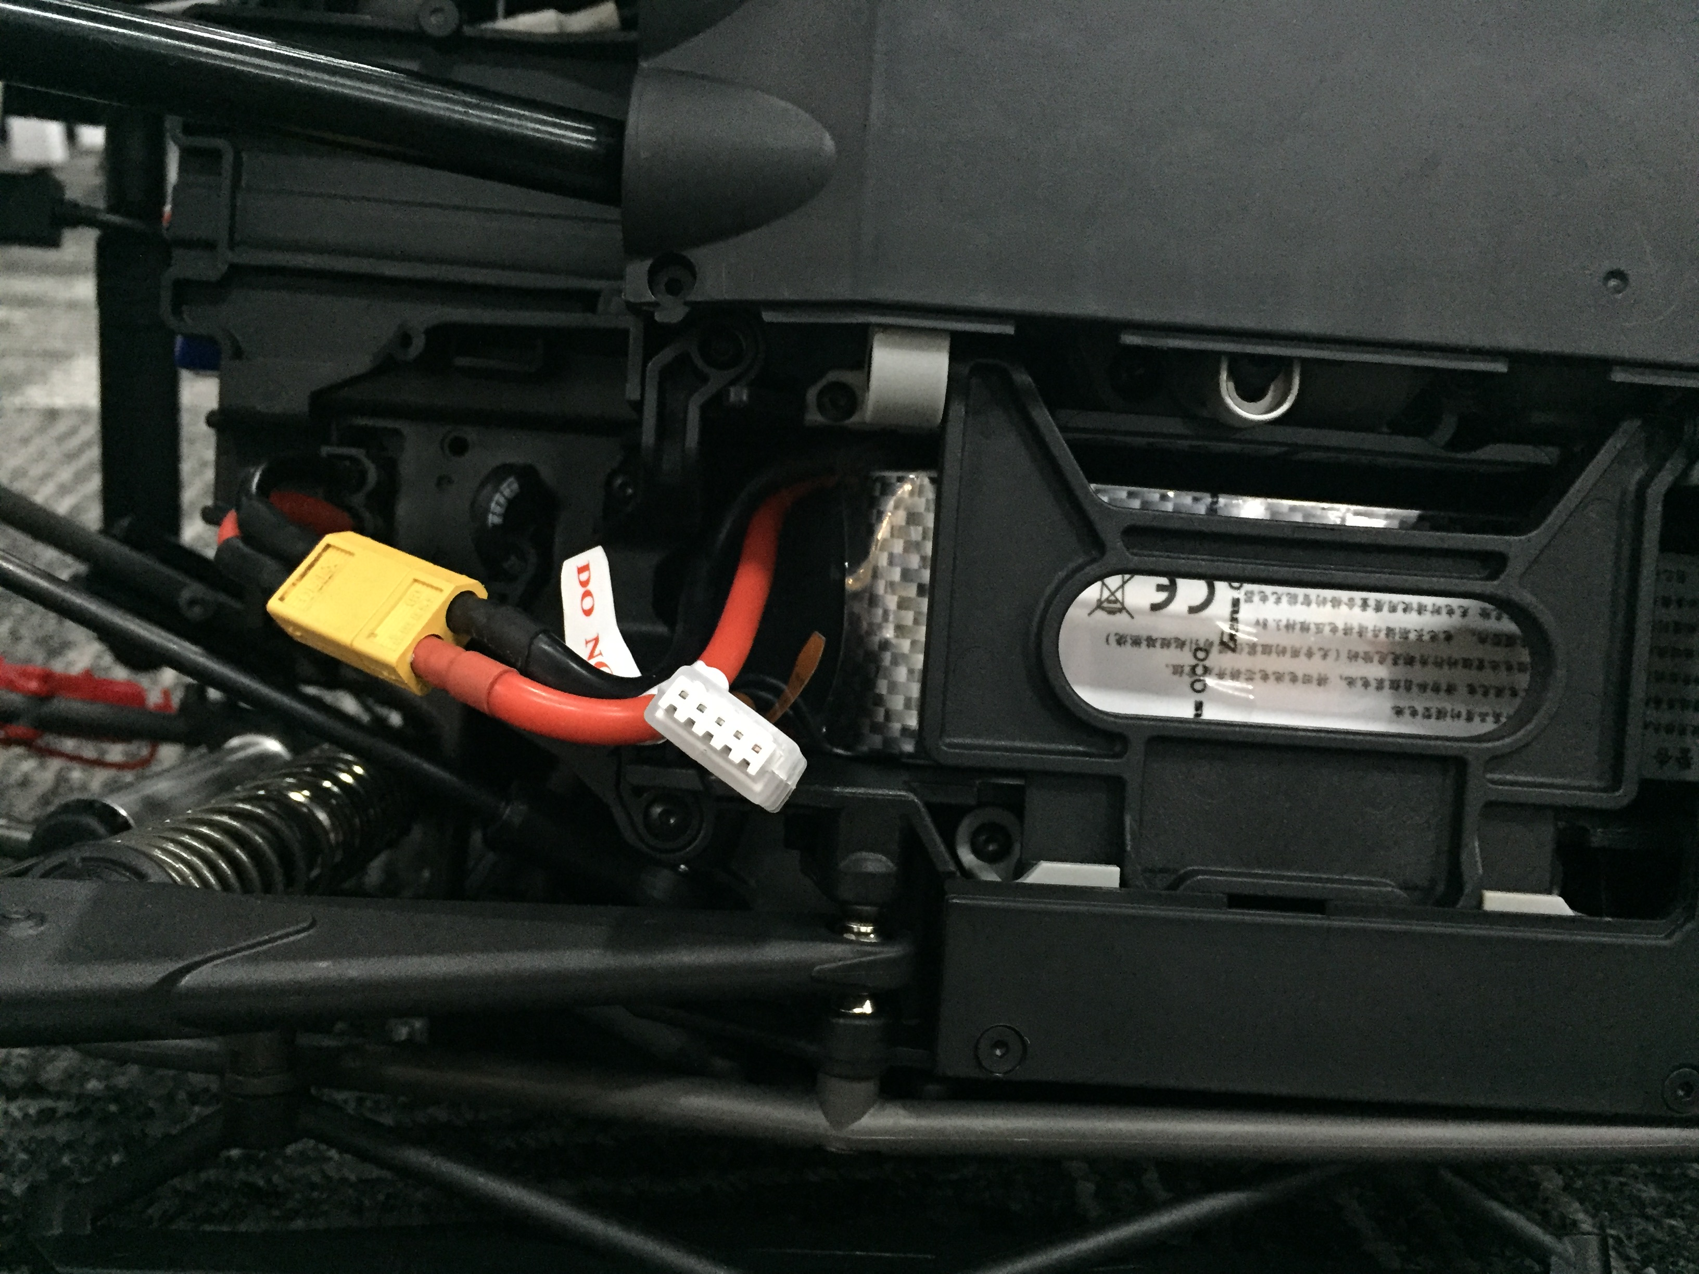

* Insert battery 3S

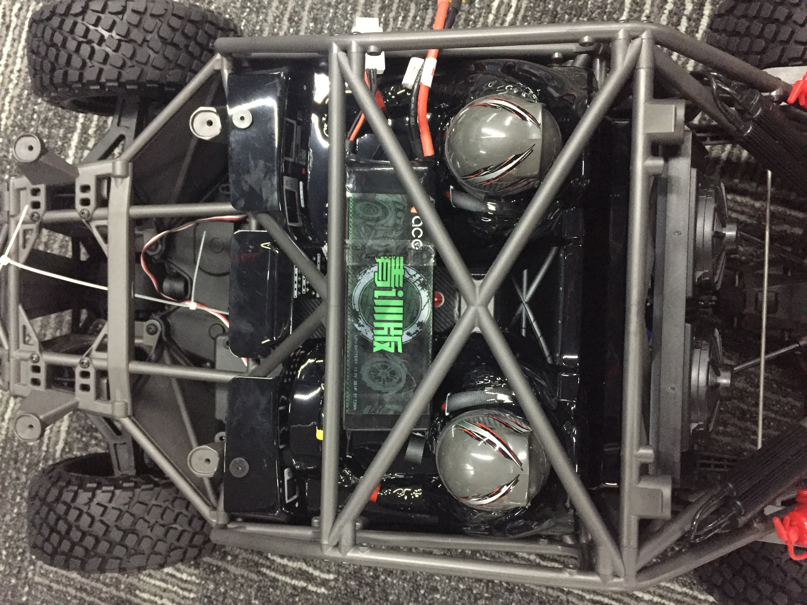

PHẦN 2: Lắp bo mạch

Bước 1: Insert antena and board FPT open to Jetson TX2

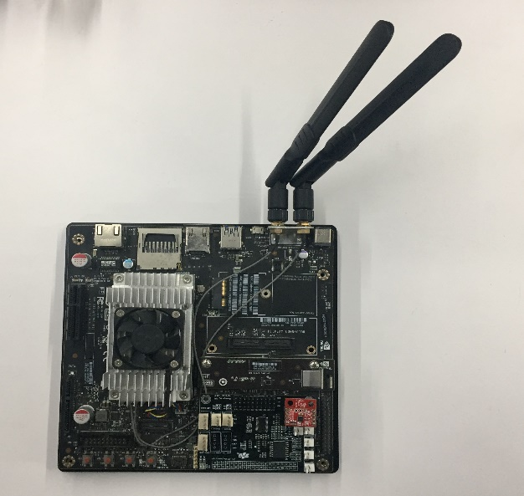

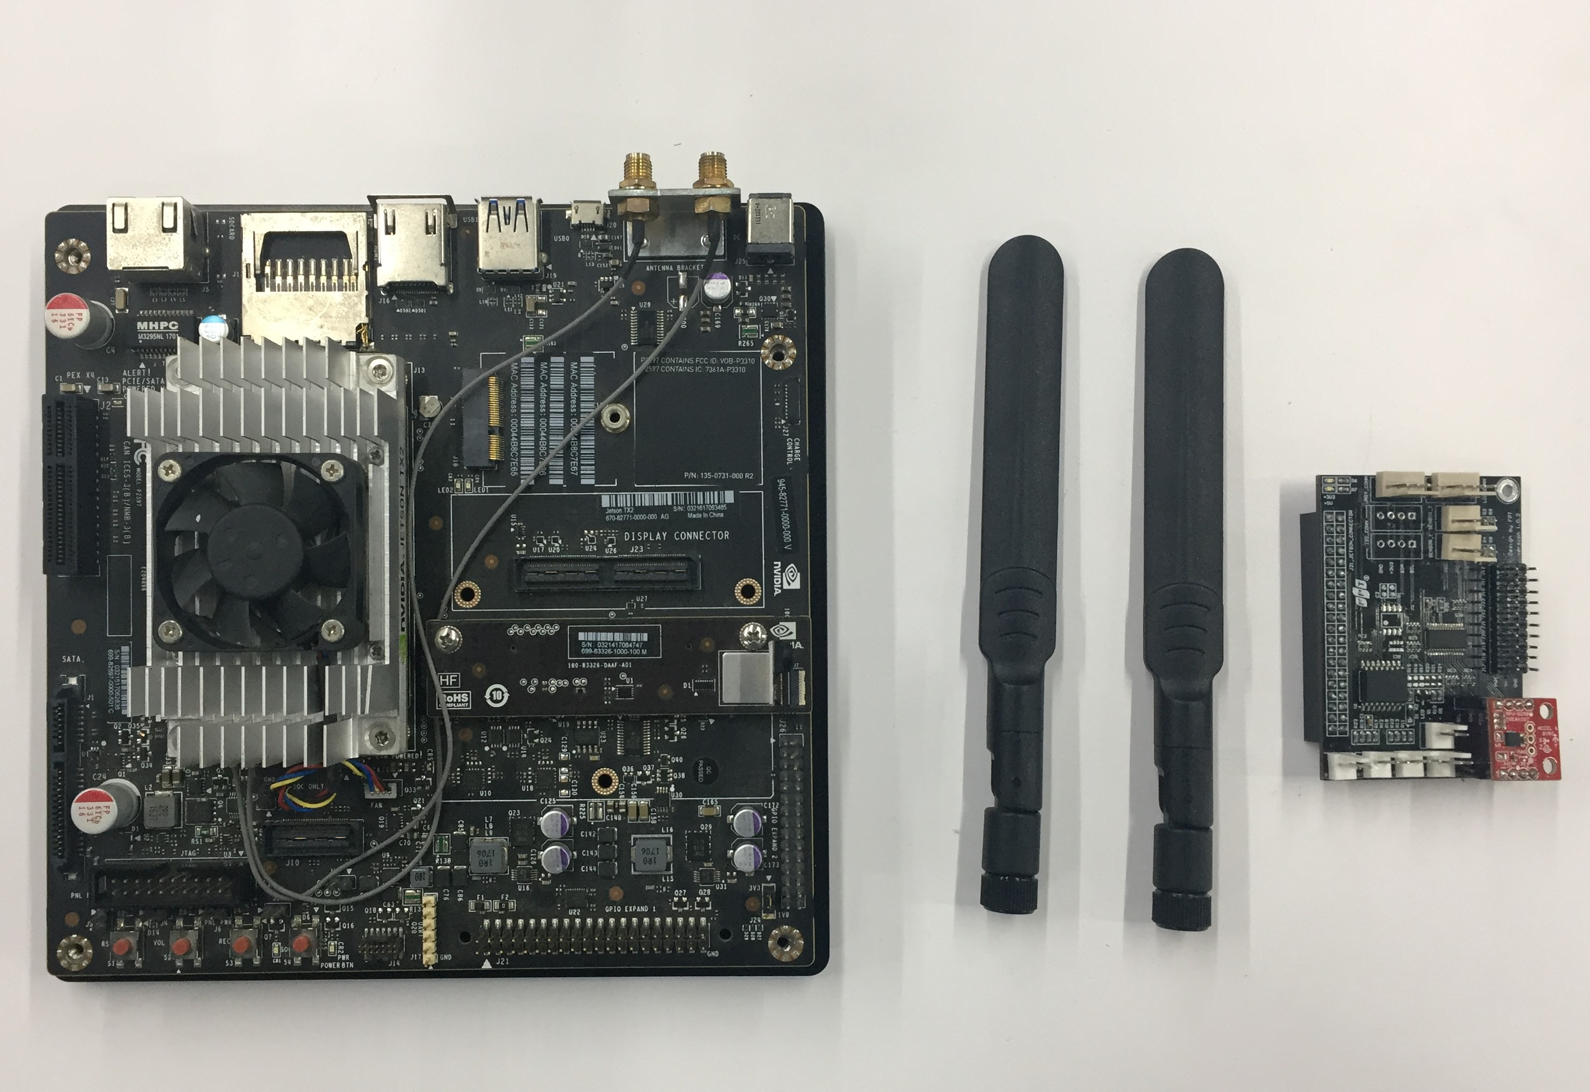

Bước 2 : Insert LCD and button, led to MICA

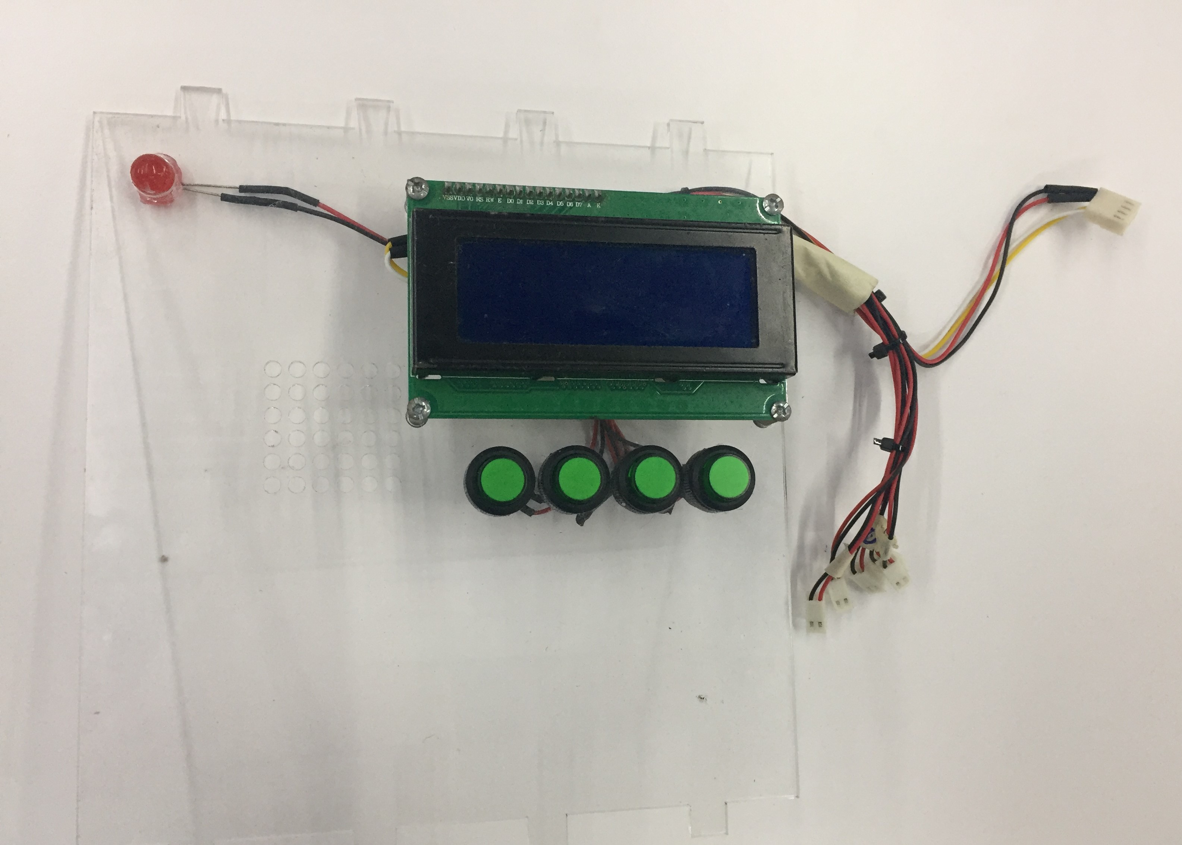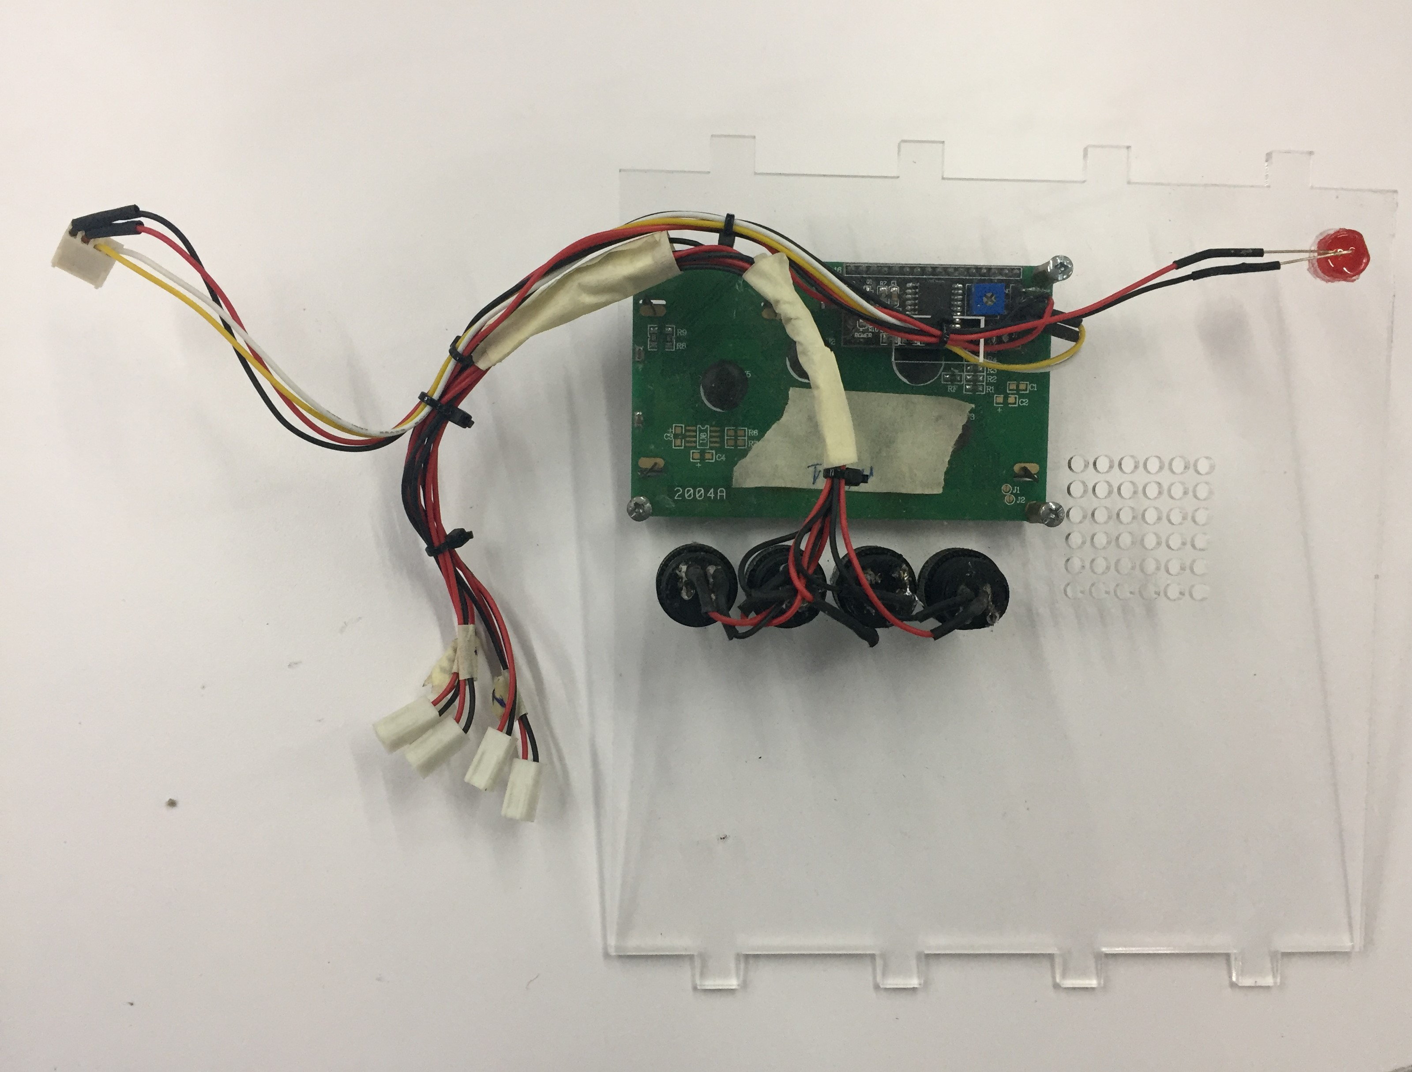

Bước 3: Installation MICA box

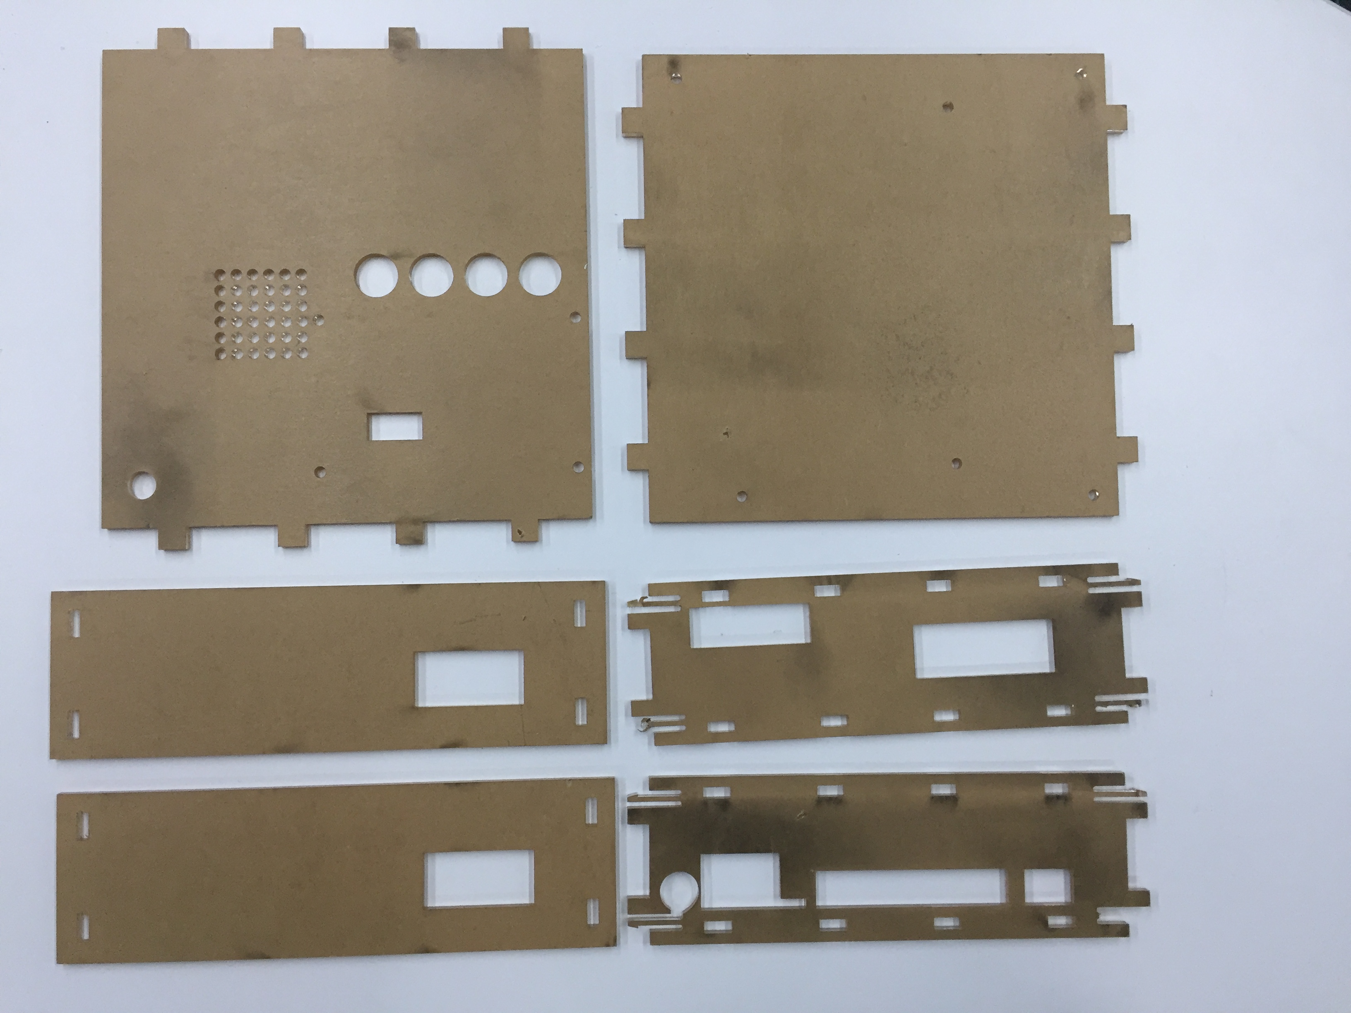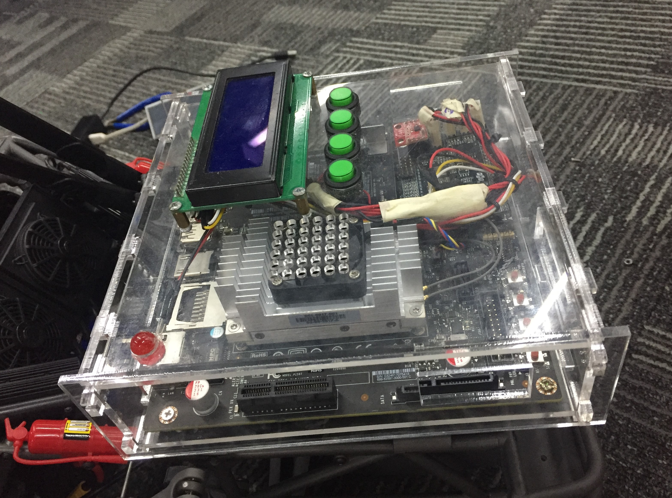

B3: Insert camera and Proximity sensor

